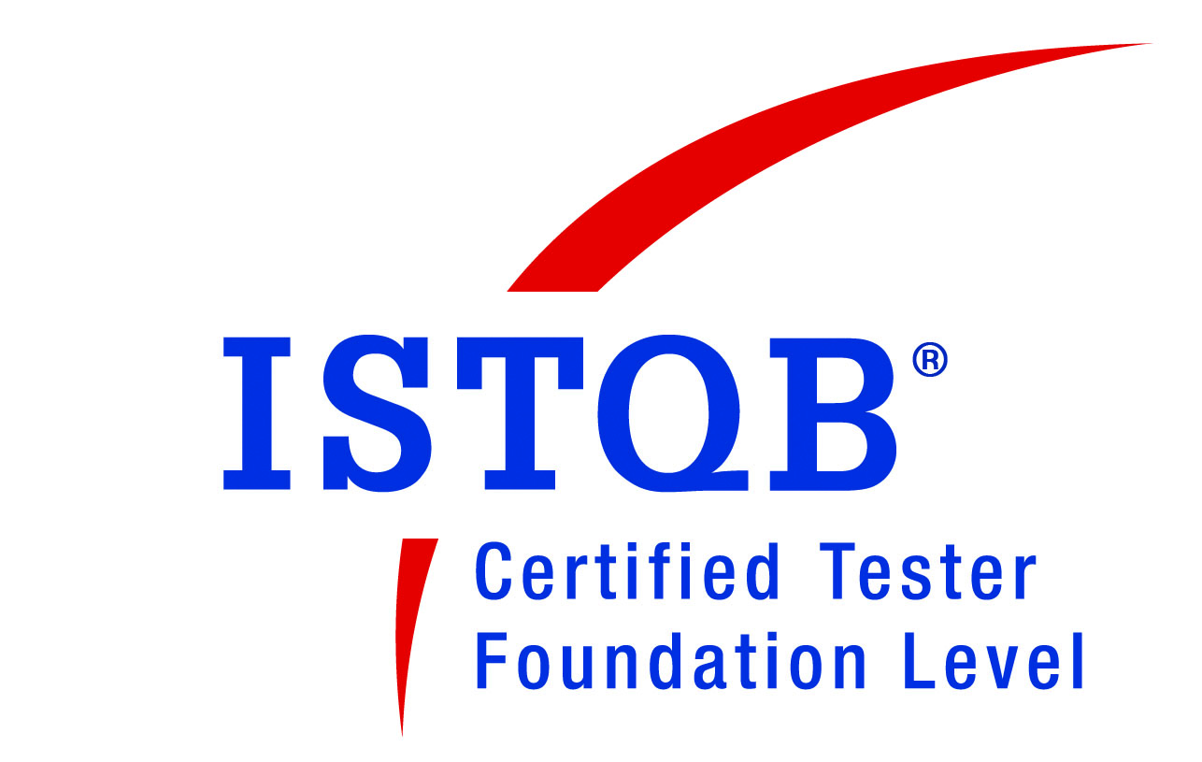
Nandini Nataraj
Mobile - +91 9972302224
E-Mail: nandini.nataraj@gmail.com
Address: #38, 7th B Main, 4th Block, Jayanagar, Bangalore - 560011

Test project Lead >>>> ISTQB Certified Tester

CAREER ABRIDGEMENT
Experience summary: 7 years of IT services and product development experience working globally distributed teams and a cross-culture mix in the team, with additional experience working in multi-vendor and independent vendor management scenarios

KEY SKILLS
- Functional/Domain skills
- Working experience as IT analyst and Test lead in health care systems, Automotive microsite web applications, ISTQB Certified
- Pre-discovery, Discovery consulting and requirements elicitation - Workshop facilitation and front-ending
- Areas: Healthcare systems (Cardio, vascular imaging & scanning equipment), Automotive microsites, Web application testing, RFP and pre-sales
- Exposure to software development and product development lifecycles
- Practical experience with best practices as recommended by BABOK
- Exposure to Agile project methodology
- Team Leadership
- Lead team of 30+ as Test lead and functional liaison between client Business analyst team and test team
- Planning and allocation of test activities, identification of workarounds for continued execution.
- Weekly & daily reports generation, reporting to internal and external stakeholders in multi-track scenario
- Facilitated internal quality checks for team and streamlining constructive quality guidelines.
- Setting up process for training and mentoring new joiners; Creating and sustaining a dynamic environment.
- Quality Management
- Working experience in test development life cycle – Functional/manual testing, automation scripting and execution of test cases, system integration testing
- Creation of test plans, test case design and test approach with eye on Requirements Traceability matrix
- Analysis of defects and defect reporting, tracking for projects.
- Regression testing during product releases. Working experience on incident management.
- Technical skills
- Experience in Test Ware Preparation: Functional Testing, UI Testing, Regression Testing, Integration System Testing, User Acceptance Testing, Defect Management and test data preparation
- Experience working on test management tools like HP Quality Center tool, Remedy
- Backend testing on SQL Server 2000/05
- Experience using Testing Tools : Mercury Quick Test Professional, TAU (Test Automation Unified- Siemens proprietary tool similar to QTP), YourKit .Net Profiler (To identify Memory leaks), PELOS (Performance and Load Suite)
- Test Management tools: JIRA, Insite, GSS, Rational Clear Quest, HP Quality Center
- Customer Relationship Management
- Attending to clients’ concerns & complaints and undertaking steps for effectively resolving them
KEY PROJECT HIGHLIGHTS

Jan 2013 – Feb 2014
Siemens Technology and Services Pvt. Ltd, India  Associate Consultant  (Team Size: 30+) |  | Project: Healthcare applications: MR Cardiac Analysis and Cardiac Flow
 |  | Key Contribution
- Functional point of contact for testing team. Analysis of specifications as given by client business analyst team.  - Facilitate workshops for detailed product enhancement understanding. Key participation from client business analysts, product architects and technical leadership team.  - First level functional check on the product build labels as confirmed by development team  - Performed release activities for incident fixes, regression of fixes into production  - Facilitated smoke testing and regression suite testing on the current product version  - Performed functional integration testing across modules  - Lead the team of 10 members from UI testing, to functional integration testing to backend testing on SQL Server 2000 |  | - Effectively performed the role of Functional single point of contact for offshore team  - Functional coordination between client Business analyst team and test team  - Timely identification of key defects on functionality, configuration and version mismatch.  - Participation in Siemens product’s continuous improvement activities.  - Business and End user training documentation and training activities  - Facilitated and anchored multiple functional and capability demo through the year  - Rated as the best performer for year 2012-13 with 4/4

Sep 2011 – Dec 2012
Siemens Technology and Services Pvt. Ltd, India  Functional Test Analyst/Lead  (Team Size: 25+) |  | Project: Healthcare applications: MR Cardiac Perfusion
 |  | Key Contribution
- Estimating the test effort and activity allocation to test team.  - Design and preparation of test scenarios. Facilitate execution of end-end test scenario and defect reporting to development team.  - Regression testing activities.  - Design and lead back-end testing using SQL server 2000.  - Created automated scripts using TAU for reports in a re-usable format and track execution on every version release.  - Facilitate defect review meetings along with all test documents.  - Assumed the role of test lead role – being single reporting point for delivery leadership for testing  - Point of communication to customers on test activities.  - Closely coordinating with the development team on the latest changes  - Configuration and data setup for smoke tests. Effective usage of IBM’s Rational ClearCase |  | - Play instrumental role in the implementation of functional testing.  - Report to developers and act as key liaison to development team  - Effectively resolve issues and queries and in the preparation and maintenance of reports and logs.  - Effectively planned and estimated test activities, identified risks and test project dependencies  - Facilitated and anchored multiple functional and capability demo through the year  - Awarded with cash prize for an innovation idea – a value add feature to ease the data retrieval mechanism in the system.  - Rated as the best performer for year 2011-12 with 4/4
Apr 2010 – Aug 2011
Siemens Technology and Services Pvt. Ltd, India  Senior Systems Engineer  (Team Size: 45+) |  | Project: Healthcare applications: Vascular Reader
 |  | Key Contribution
- Understanding requirements from BA documentation, maintain team clarification log.  - Author detailed test cases as per template  - End-end functional test execution, working closely with other test owners  - Defect tracking and participation on defect triage meetings – along with client business analysts, test lead, technical lead  - Bi-weekly reporting of defect analysis during integration and system integration test phases  - Updates to HP Quality center on observation, acceptance of the defect fix  - Boundary analysis and negative test scenario identification.  - Created a winning approach to identify the test cases and scenarios  - Monitor using.Net profiler for system memory leaks. Effective usage of PELOS (Performance and Load suite) |  | - Appreciated for keen attention to detail, while performing requirements documentation study  - Defect-free authoring of test cases and mapping  - Performance and load testing anchor, and Effective usage of tools like HP Quality center, PELOS, .Net profiler  - Well acknowledged for effectively reporting defects and observations to developers and act as key liaison to development team

Feb 2007 – Mar 2010
Adea Technologies Pvt. Ltd, India  Software Engineer/Test Engineer  (Team Size: 15+) |  | Project: Web applications: Dealer site, Next brand site, microsite for a global auto giant
 |  | Key Contribution
- Execution of Functional and UI test cases.  - Participation in requirements understanding sessions.  - Custodian of key activity status tracker. This was a common report shared with client and client’s delivery team.  - Preparation of Test Cases for User scenarios based on Functional Specifications  - Involve in Peer review Test Cases.  - Conducted GUI and cross browser testing for application.  - Conducting Regression testing for different releases of application.  - Integration testing for different modules.  - Ensured 100% QA focus on all deliverables and related documents pertaining to the project.  - Effective usage of JIRA for defect reporting and Test Management activities.  - Execution of Test Cases and updating the results.  - Preparing weekly defect status report. |  | - Effectively coordinate in reproducing defects. Estimates involving identifying the type of issue and the criticality  - Key member during all phases of testing – Functional / System integration / Regression  - Worked closely with developers during the QA with respect to the application.  - Pro-active monitoring during various build stages and identified critical issues to follow-up with technical team.  - Run periodic automation processes to support regression testing  - Assist the Test Lead, where required, with preparation and review of Test Artifacts / Documentation  - Awarded with ‘Instant Recognition Award’ in first year for being an outstanding performer.  - Rated as best performer in the team for 3 consecutive years (2008, 09, 10).  - Awarded best team for the year 2009 - was a key team member

Other projects
Adea Technologies Pvt. Ltd, India  Technology Account Manager  (Team Size: 6+) |  | Project: RFP, Pre-sales and TAM for global auto giant’s vendor
 |  | Key Contribution
- Member of the RFP and proposal screening team  - Involve in RFP formulation, publish and follow-up with multiple vendors  - Liaison with different stakeholders during the proposal stage through project bidding phase |  | - Effectively collaborate with multiple vendors during the RFP and proposal stage  - Key contribution to the templates and guidelines in pre-sales process  - Member of core team including customer business and technical contacts in RFP formulation stage

IT TOOLS AND SKILLS SUMMARY

- Web Technology: HTML, CSS
- Operating Systems: Experience working on Windows 2000/XP and MAC
- Web Servers: Apache 2.0.16, Tomcat 5.5
- Configuration Management Tools: Tortoise SVN, IBM Rational Clear Case
- Testing Tools: Mercury Quick Test Professional, TAU (Test Automation Unified- A Siemens proprietary automation tool similar to QTP), YourKit .Net Profiler (To identify Memory leaks), PELOS (Performance and Load Suite)
- Test Ware Preparation: Functional Testing, UI Testing, Regression Testing, Integration System Testing, User Acceptance Testing, Defect Management
- Test Management: JIRA, Insite, GSS, Rational Clear Quest, HP Quality Center
- Imaging Tools: GIMP2, Adobe Photoshop, MSPaint
- Repository: Tortoise SVN, Rational clear case and Team Foundation Server (TFS)

EDUCATION
- Bachelor of Engineering in Computer Science, Visveshwaraya Technological University – 2002 - 2006.

Certification
- ISTQB Certification, International Software Testing Qualifications Board – 2012
- Siemens FOCUS certification on industry and software test processes - 2012

ADDITIONAL INFORMATION

Visa : Australian work-permit valid till 2018
Nationality : Indian
Passport number : K2628133
References available upon request

